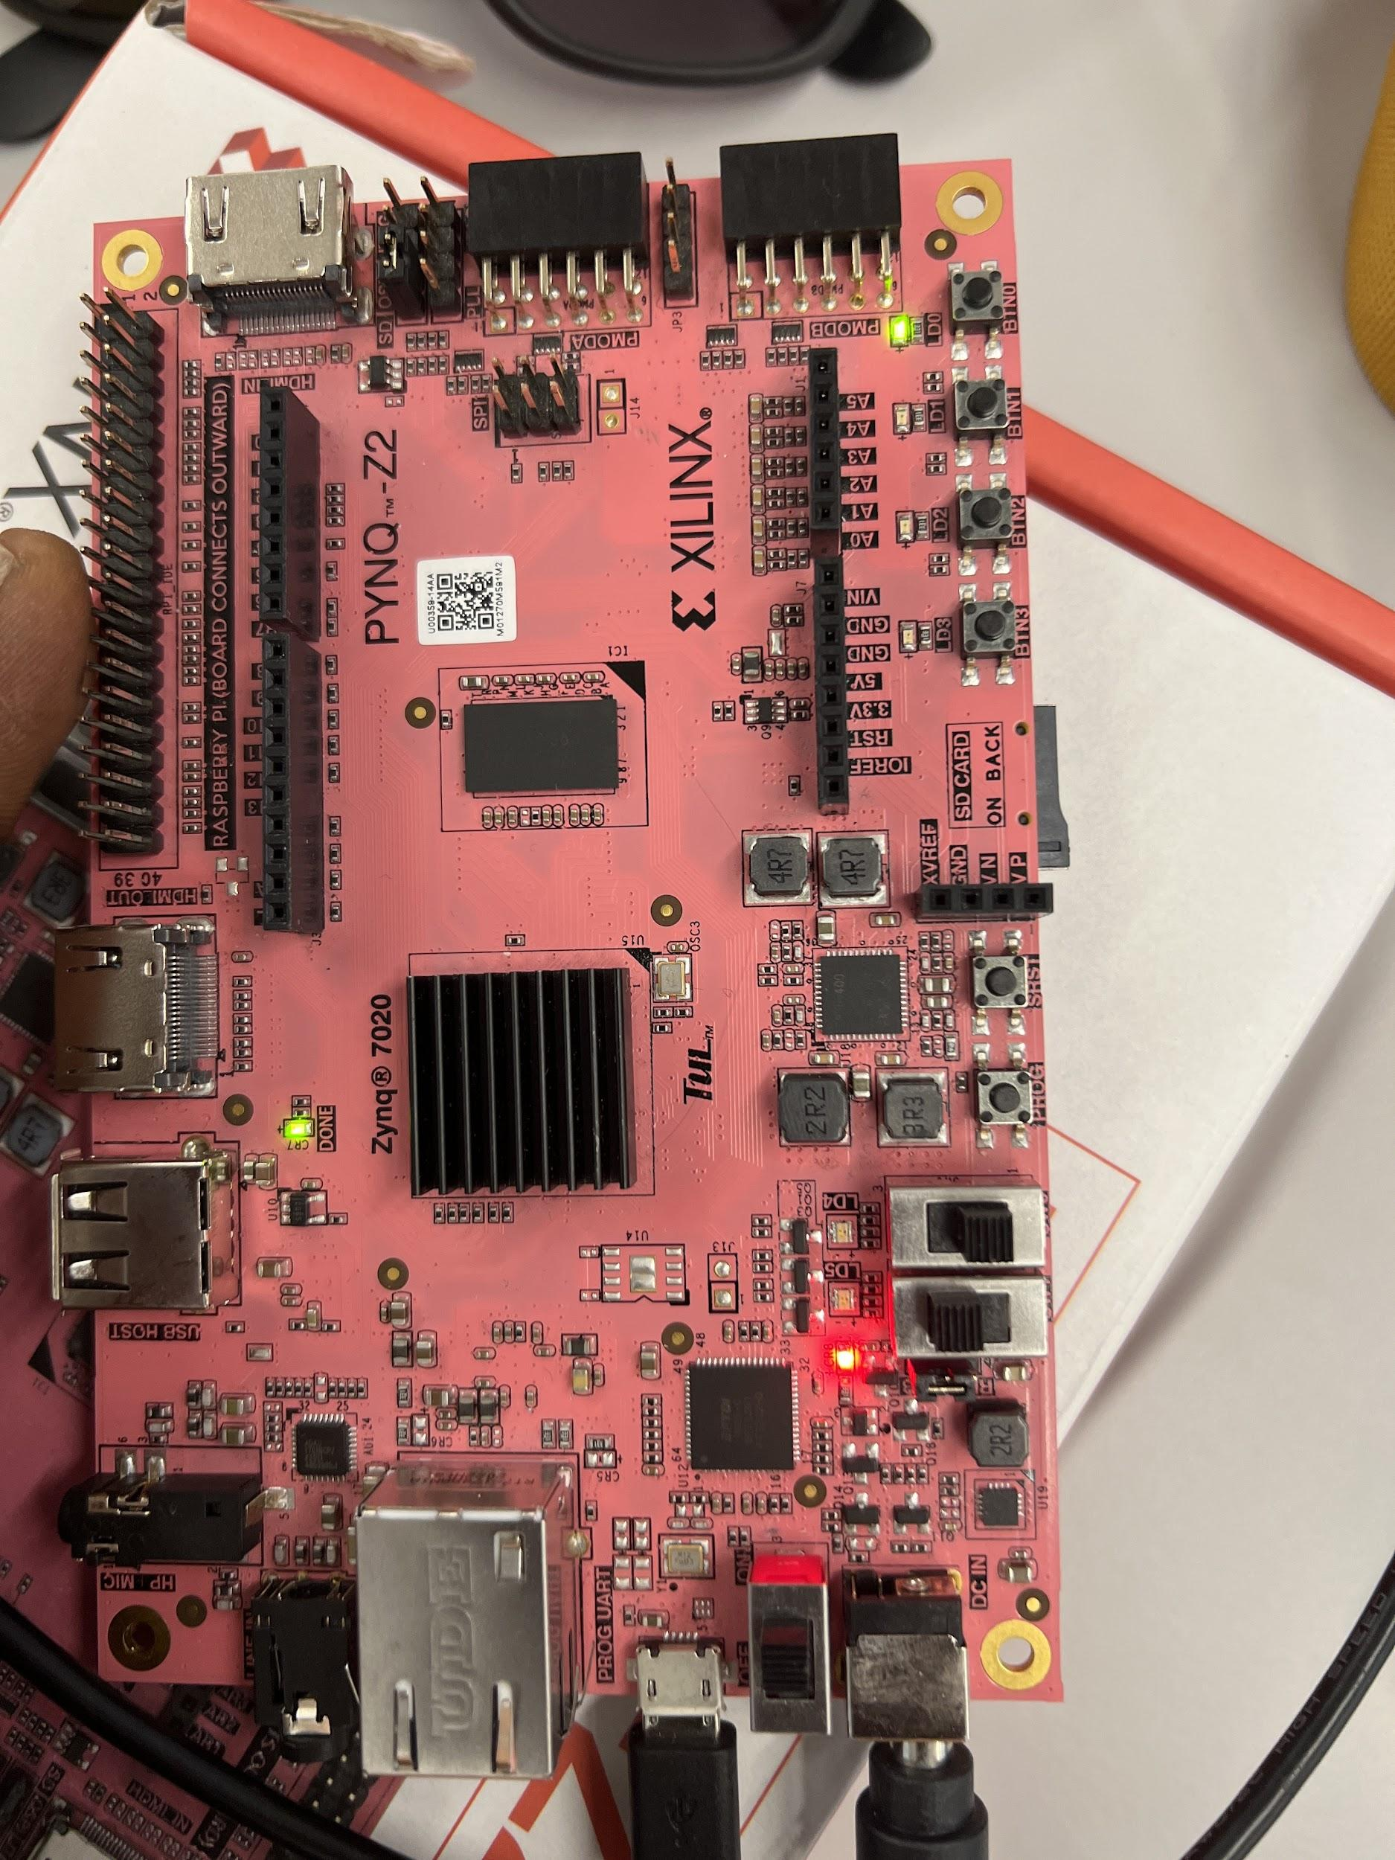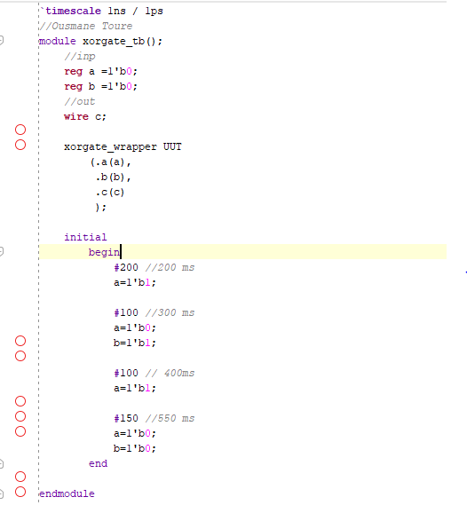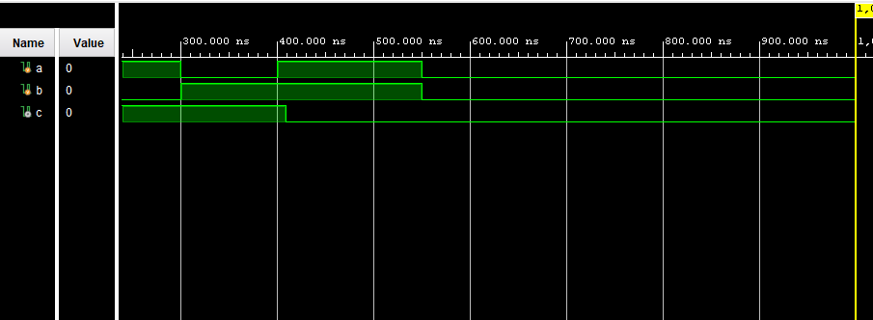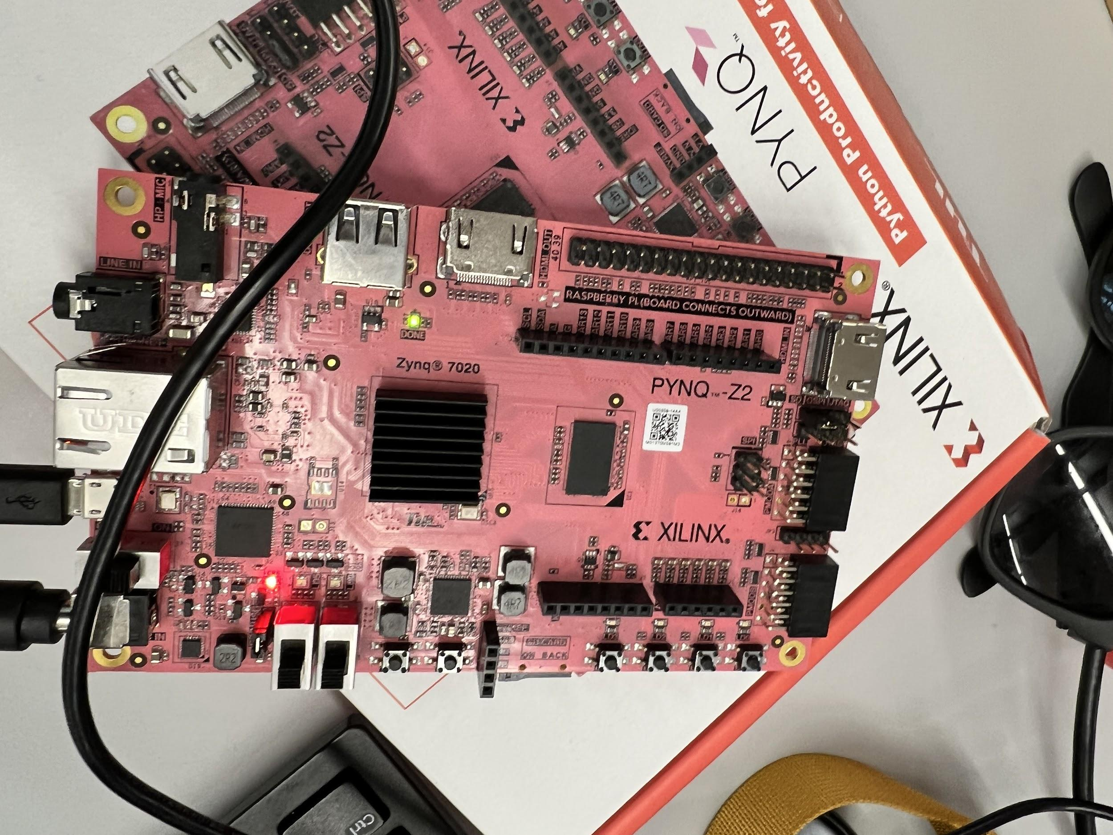

During the lab, the waveform refused to change after editing the NAND circuit gate delay from 3 to 1. When changing the circuit gate delay we would of witnessed a more “clean” signal as stated in the Lab manual figure 12-15 